Julia Eileen Gillard
Biography

GIRL POWER! This legendary, notable Aussie women has inspired
millions of young girls to do great things, LIKE BECOMING THE FIRST
FEMALE PRIME MINISTER OF AUSTRALIA!!!!

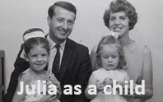
Julia Eileen Gillard was born September 29th 1961 in Barry, U.K. Gillard was a young girl aged four, when her family decided to migrate to Adelaide, South Australia. The Gillard family left from Southampton on the 7th February 1966 under Australia’s assisted passage migration scheme when Australia would let UK citizens come to Australia to be employed and increase the population. They were called “ten pound poms”. The Gillard family settled into their new home in Adelaide, South Australia.

Julia and her sister Alison enrolled into Mitcham Primary School and then went to Unley High School. In high school, Gillard was an excellent student and became the star debater. When she enrolled at the University of Adelaide in 1979, she joined her university's political labour club.

Gillard worked as a lawyer until 1987 when she was elected into the House of Representatives and joined the Australian Labour Party. Gillard didn't stop there, she entered the shadow cabinet in 2001, and in 2006 became the deputy leader of opposition. In 2007 she became Australia’s first deputy Prime Minister and in 2010 became the first women Prime Minister. GIRL POWER!!!!
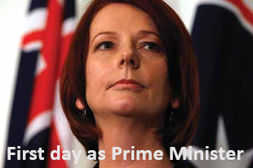
Some of Gillard’s most notable achievements as the first female prime minister of Australia, included the creation of the National Broadband Network, the biggest project in Australia. The NBN is high speed internet that allows easier access to knowledge and information which is a huge bonus for all schools.

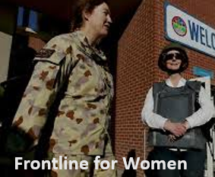
In addition, Gillard has made it possible for Australian women to fight on the frontline by lifting restrictions of gender. This is excellent because it opens up new career options and makes men and women equal on the battlefield.

Another notable action that Gillard undertook was to apologise in a formal way to all the people who were affected by “forced adoption” rules between the 1950s and 1980s. For all the people affected it was an extremely emotional moment of recognition. This touched many people’s hearts around Australia.

Gillard had many notable achievements in the health industry including trying to prevent people from smoking by pushing “plain paper packaging” on the cigarette packets to try and save lives. This action will hopefully prevent people from smoking and answer all the peoples prayers whose loved ones have died of smoking related diseases.

These are the reasons why I think Julia Eileen Gillard is an extremely notable Australian and should definitely be recognised for her amazing achievements which have affected the lives of millions. GIRL POWER!!!

Bibliography:
- “Julia Gillard” https://www.buzzfeed.com/search?q=julia%2Bgillard Accessed 23 April 2016
- “Australia’s Prime Ministers” http://primeministers.naa.gov.au/ Accessed 24 April 2016
- “Sophie’s PM portrait gets pride of place” https://www.canberratimes.com.au/national/act/sophies-pm-portrait-gets-pride-of-place-20130929-2umue.html Accessed 30 April 2016
- “Julia Gillard” https://en.wikipedia.org/wiki/Julia_Gillard Accessed 30 April 2016
- www.Youtube.com
- www.museumvictoria.com.au

Not all of these bibliography references are accurate - can you see why?

